Multimodal and Hybrid Image Analysis of
Synthetic Fluorescence Microscopy Images

1. Methods and Task Results
A synthetic nuclei dataset (80 train, 20 validation, 12 unseen test images) was processed as 256×256 grayscale images. The workflow combined direct multimodal description, classical Otsu segmentation, U-Net segmentation and a structured LLM interpretation pipeline.

Task 1 — Direct multimodal description
The representative image was selected by mean-intensity proximity to the dataset mean. A naive prompt produced an unsupported “electron microscope” interpretation, whereas the constrained prompt returned fluorescence microscopy, tissue_type = “uncertain”, visible features and image-quality fields. Llama 3.2 Vision was attempted but failed locally with the Ollama mllama architecture error; Qwen2.5-VL 3B was therefore used with the same procedure.
Optimised Task 1 : Describe only visible evidence; do not diagnose or invent tissue, organ, stain, species or acquisition method. If unsupported, return “uncertain”. Return valid JSON with modality, tissue_type, notable_features and image_quality {overall, contrast, noise, issues}.
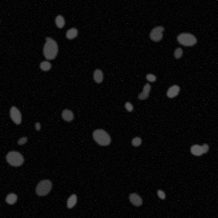 | 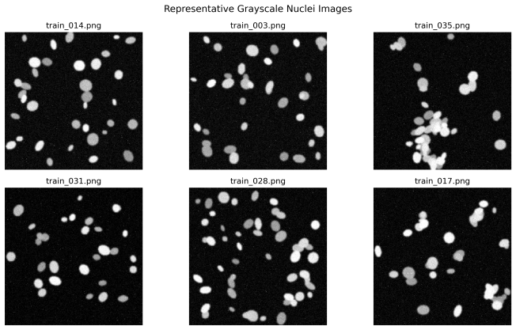
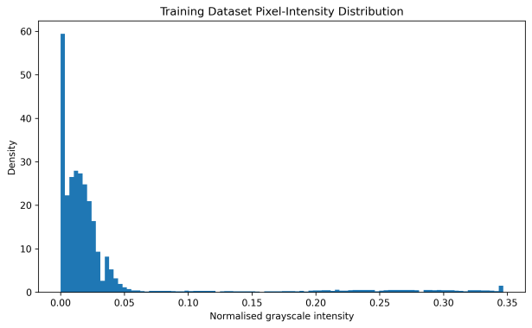
Figure 1. Representative VLM image, sample grayscale images and training intensity distribution.

Task 2 — Classical segmentation and numbers-first LLM
After Otsu thresholding, morphology, and connected-components labelling was regionprops_table. The selected image had 24 objects (average area 172.75 px, eccentricity 0.703, solidity 0.955, and foreground proportion 0.063). The only deterministic parameters that were supplied to the LLM were those, thus enabling
Optimised Task 2 : Only use numerical measurements provided; don’t make up measurements for tissues, diseases, organs, cells types, stains, organisms, or acquisition technique. Give back valid JSON with description, n_objects, density_class, shape_regularity, and quality_flag; Python-generated values shouldn’t be altered.

Task 3 — U-Net segmentation
A small PyTorch U-Net (483,153 trainable parameters) was trained for 15 epochs with Adam and BCE + Dice loss. Evaluation used the untouched 20-image validation set.
Method | Mean Dice | Mean IoU
Otsu | 0.9782 ± 0.0027 | 0.9574 ± 0.0052
U-Net | 0.9960 | 0.9921
Improvement | +0.0178 | +0.0348
U-Net achieved higher Dice on all 20 validation images. Otsu remained a strong baseline because foreground and background were well separated, but U-Net better preserved spatial boundaries.
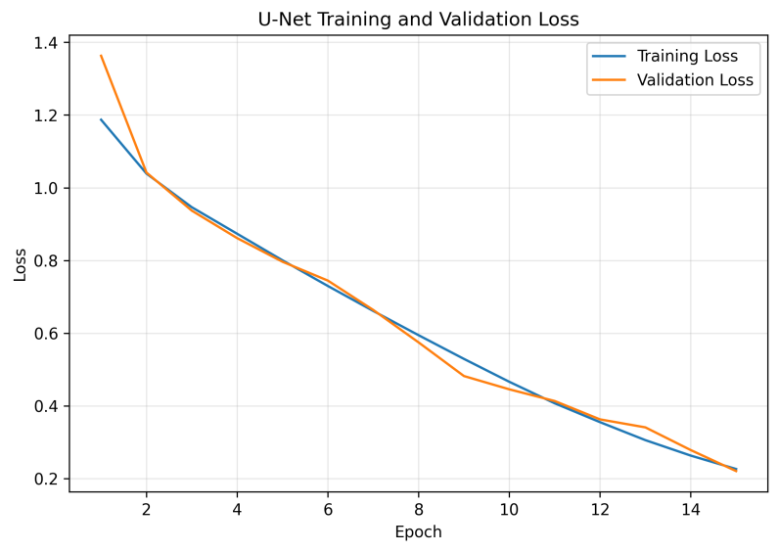 | 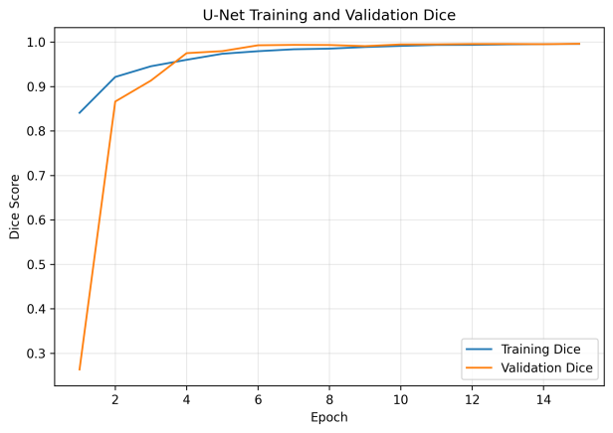
Figure 2a. Training/validation loss and Dice curves.
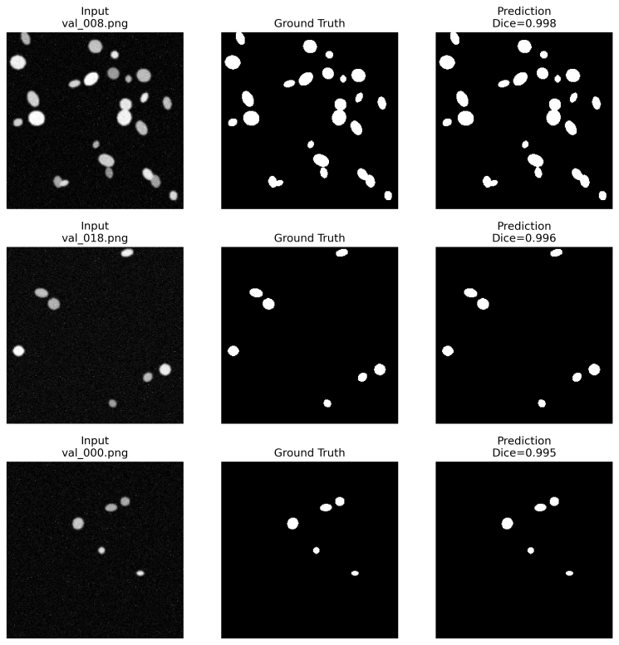
Figure 2b. Input | ground truth | U-Net prediction on three validation images.
Extra credit — loss ablation: BCE, Dice and BCE+Dice were compared in matched short runs. BCE achieved the highest validation Dice (0.9954) for this dataset/configuration.

Task 4 — Hybrid pipeline
All 12 unseen test images were processed as: image → U-Net mask → connected components → regionprops → deterministic source record → constrained LLM JSON → narrative → DataFrame/CSV. Python computed image_id, n_objects, mean_area, density_class and quality_flag; the LLM was not allowed to change them. Structured-output validation passed for 100% of test records.
Optimised Task 4 : Treat the supplied U-Net/Python record as the source of truth. Return JSON containing exactly image_id, n_objects, mean_area, density_class, quality_flag and one concise narrative. Do not change source fields or invent tissue, disease, organ, stain, species or biological identity.
Mean objects  20.67 | Mean area  254.83 px | Density split  6 low / 6 moderate

2. Critical Analysis and Required Questions
1. Which description was more useful and which was more trustworthy?
While the VLM was better at making something look pretty, the numbers-first method was more reliable. The VLM had hallucinations of electron microscopy and microorganisms, while the numbers-first method used Python measurements. The optimised VLM increased its reliability through the inclusion of the option “uncertain.”
2. Did U-Net improve on Otsu?
Yes. Mean Dice increased from 0.9782 to 0.9960 and mean IoU from 0.9574 to 0.9921. U-Net was better on every validation image. Otsu remained strong on high-contrast synthetic images, but a single global threshold is less flexible when intensity or object boundaries vary.
3. What do the Dice and IoU values mean, and where did errors occur?
The Dice and the Intersection over Union (IoU) metric are used to assess the similarity between the predicted mask and the ground truth mask . The higher the number is toward 1 , the more similar the two are . The dice and IoU of 0.9960 and 0.9921 respectively show that the two masks are highly similar.
4. Where can the LLM hallucinate, and how was this reduced?
Risk is highest in direct image description and open-ended narrative generation. Mitigations were explicit non-diagnostic constraints, uncertainty language, deterministic numerical source fields, strict JSON schemas, post-generation validation and a deterministic fallback.
5. Would this system be trusted clinically, and what would most improve trustworthiness?
No. High performance in synthetic validation does not necessarily imply clinical generalization. The one improvement that is most useful is that of independent validation on a large set of real microscopy data, well annotated and diverse, with uncertainty calibration and human review.
Interpretation note: Density, shape and quality categories were project-defined analytical bins, not clinically validated biological classifications.

3. Extra-Credit Robustness
Heavy Gaussian blur (sigma = 4) was applied to one test image and propagated through the complete pipeline. The clean-versus-blurred U-Net masks gave Dice = 0.7110 and IoU = 0.5516, showing a substantial segmentation change. Feature measurements and the narrative also changed, so the earliest detectable failure occurred at the segmentation stage; the LLM mainly propagated altered upstream evidence.
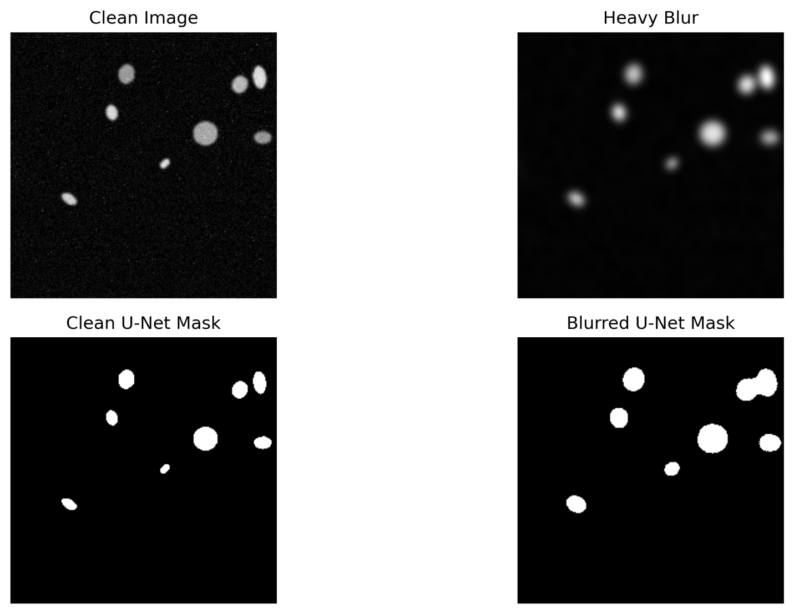
Figure 3. Clean image, heavy blur, clean U-Net mask and blurred U-Net mask.

4. Conclusion
The hybrid pipeline combined interpretable classical measurements with high-accuracy U-Net segmentation and constrained LLM reporting. U-Net clearly improved on Otsu, while numbers-first prompting and JSON validation reduced hallucination risk. The results are promising for a controlled synthetic dataset but are not evidence of clinical readiness.

5. GitHub Link
GitHub Link : https://github.com/gautam25aas/AI-imaging-Coding-Case-Study-and-Report

